1. Intellij IDEA supports marking objects with labels. We can assign labels to objects.   
   During debugging, we can reference those objects using labels to create conditional breakpoints.  
   Let’s see an example.
2. Let’s say we have scenario where we have a list of persons 🡺 personList and we want to halt the execution for a breakpoint when a particular element in the list is reached.  
   For this we will give a label to the element and then will define the conditional breakpoint using that label.
3. 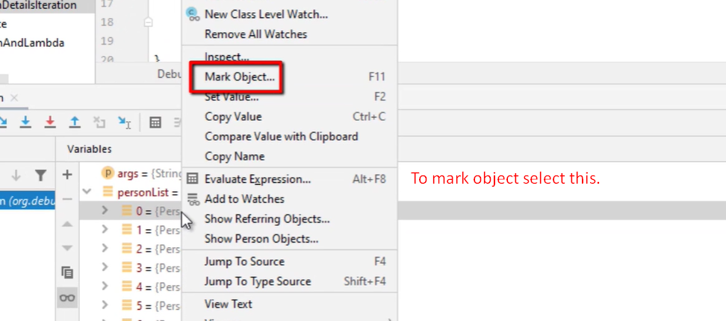
4. 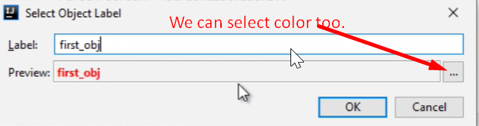
5. 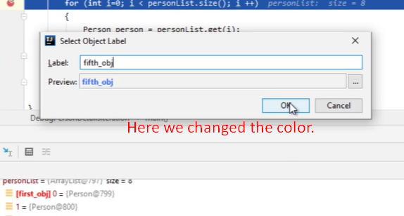
6. 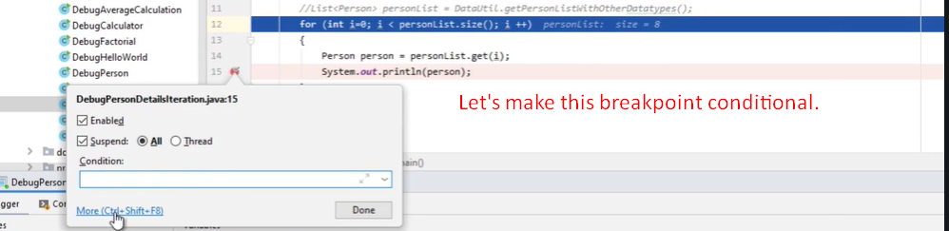
7. 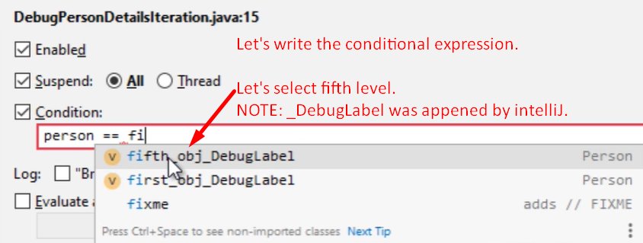
8. 
9. 